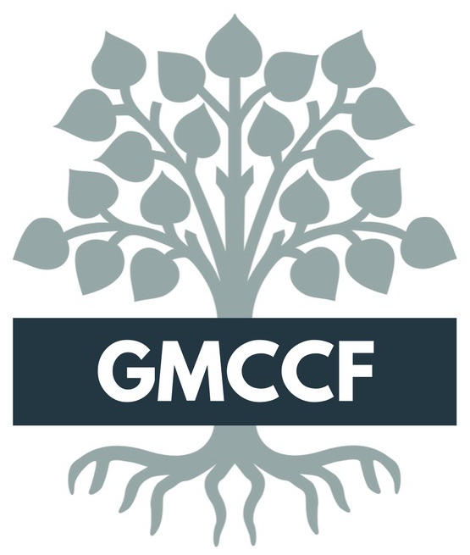
Grant # ____________ (For Foundation Use)

1217 North Sixth Avenue, Suite 3
(515) 462-1891 tom@madisoncountydevelopment.com

Please submit the original and 16 copies of the four page application (plus any attachments requested, or you deem necessary) to The Foundation.
(The application will not be considered unless copies are submitted.)

The application deadline is 4:00 PM, March 27, 2020.

Project Title: ________________________________________________________________

Organization Information
Name of organization: _________________________________________________
Legal name (as listed with IRS) (If different from above):_____________________
Organization Address: ________________________________________________
Employer Identification Number (EIN): __________________________________
Phone ___________ Fax ___________Website ___________________________
Name of contact person regarding this application: __________________________
Relation to organization: ______________________________________________
Phone: ____________________ E-mail: _________________________________

If your organization is not an IRC 501(c)(3) you must have a fiscal sponsor that is either a 501(c)(3) or
170 (c)(1) organization. (Applications submitted without fiscal sponsor will not be considered.) See page 4.
Organization: ________________________________________________________

Total Cost of Project: _____________ Amount Requested: ______________

Overview
Brief Description of Organization: ________________________________________
____________________________________________________________________

Brief Description/Explanation of Project:___________________________________
____________________________________________________________________

Type of Request (check one): Capital Based or Program Based

Program Based: Operational, activity, general programmatic support
Capital Based: The building of or physical improvement of something

Project Focus Area (check one):

Arts/Culture/Humanities Human Services Education Environment/Animals

Public/Society Benefit Health Other

Have you received funding from The Foundation previously? _____Yes ____No
If yes, when? __________
Continued

PAGE TWO
The Greater Madison County Community Foundation

Are you requesting for the continuation of a previously funded Foundation project? __Yes __No.
If yes, please indicate reason. __________________________________________________
__________________________________________________________________________

What is your accounting year? (Mo) to (Mo) ____ to ____.

Describe your organization’s charitable purpose, program activities, and population served:
___________________________________________________________________________
___________________________________________________________________________

List any major changes that have taken place in your organization in the last two years. ___________________________________________________________________________
___________________________________________________________________________

Briefly describe your organization’s local history and major accomplishments.
___________________________________________________________________________
___________________________________________________________________________
___________________________________________________________________________

Request Summary
Describe the proposed project, including the goals and objectives. Discuss the community need for the project, the benefit(s) for the community as a result of the project and the community support for the project and any other information you deem to be significant. (Attach a single sheet if necessary.)
____________________________________________________________________________
____________________________________________________________________________
____________________________________________________________________________
____________________________________________________________________________
____________________________________________________________________________
____________________________________________________________________________
____________________________________________________________________________

Indicate desired impact and how you will measure and evaluate the results of the project. Be specific regarding community needs/issues your project will address.
____________________________________________________________________________
____________________________________________________________________________
____________________________________________________________________________
____________________________________________________________________________

Considering the availability of project funding, describe your timeline for the project including expected start and completion dates.__________________________________________________________
____________________________________________________________________________
____________________________________________________________________________
____________________________________________________________________________

Population served (estimated #): _________________

Continued

PAGE THREE
Greater Madison County Community Foundation
Project Budget

Expenses
Source Amount
Land Purchase | $
Professional Services | $
Construction Costs | $
Equipment Purchase | $
Construction Supplies | $
Training Costs | $
Personnel Costs | $
Other Expense | $
Total:

Income
Source Amount
Sponsor Cash | $
Federal Gov. Grants | $
State Gov. Grants | $
Private Foundations | $
Sponsor In-Kind* | $
Private In-Kind* | $
County Foundation | $
Other Income | $
Total:
(Should equal cost of total project.)

*In-kind gift: when a foundation or other entity contributes a good or service in lieu of providing monetary grants. In-kind contributions support the daily operations of an organization.

Approval Agreement from Applicant Organization
We approve submission of this grant request and certify that the purpose of this request is charitable and that any funds received from the Community Foundation will be used solely for the project stated in this application.

Board Chairman or designated representative: ___________________________
(Signature required)
Printed name of Chair, or representative: _______________________________

Date: _________________
------------------------------------------------------------------------------------------------------------
Applications are due March 27, 2020
Please deliver to:
Foundation Office
C/O Madison County Development Group
1217 North Sixth Avenue, Suite 3
Winterset, Iowa 50273

Applications will not be accepted electronically.
Thank you!
Questions should be directed to the Foundation Administrator (515) 462-1891 or Foundation President Jerry Parkin at 515-344-8497.
Continued
PAGE FOUR
Greater Madison County Community Foundation

If organization applying is not a 501 (c)(3) this form must accompany the grant application.

Fiscal Sponsorship Agreement

Date: ___________

Fiscal Sponsor (Legal Applicant): ______________________________________________

Fiscal Sponsor Contact Person and Email: ______________________________________

Fiscal Sponsor Full Mailing Address: ___________________________________________

Sponsored Organization Conducting Requesting Funding: _________________________

Project Name: _______________________________________________________________

_________________ (hereafter referred to as The Sponsor) has agreed to serve as a fiscal/program sponsor for
the______________________________ (hereafter referred to as the Sponsored Org.) as outlined in the attached application
and supporting materials.

The Board of Directors of The Sponsor has passed a resolution adopting the Sponsored Org.’s project as a program or
project consistent with the Sponsor’s purpose and mission. The Sponsored Org.’s financial activities will be accounted
for as a program of The Sponsor for IRS auditing and financial reporting purposes.

Since the Sponsored Org. is not recognized by the IRS as a charitable tax-exempt entity, The Sponsor must exercise
full control over the Sponsored Org.’s financial administration, management and disbursement of funds resulting from
this grant application. The Sponsor has delegated ______________________ (name of person/s) as responsible for
fulfilling of these accounting and reporting functions subject to the ultimate authority of the Board of Directors of The Sponsor.

The Sponsor is responsible for ensuring completion of timely reports and submission of necessary financial statements
to the Community Foundation’s Administrative Office (contact info below). Failure to insure timely reporting on behalf of
the Sponsored Org./Sponsor will also result in a loss of good standing.

This agreement will be in effect from the date of a grant award to support the above-named project until the grant funds are
expended and the final report has been submitted and accepted.

We agree to the terms stated above in this agreement:

Legal Applicant/ Fiscal Sponsor Representative Signature: _____________________________________

Printed Name: __________________________________ Date: __________________________________

Sponsored Organization Representative Signature: ___________________________________________

Printed Name: __________________________________ Date: __________________________________

*Attach to this agreement the Fiscal Sponsor’s 501(c)(3) Tax-Exempt Determination Letter or comparable proof of charitable exemption. (i.e. a letter from a City, confirming their status as a government entity. Contact our Administrative Office with questions, or for examples of a letter from a City.)*

Definitions/Explanations

Fiscal Sponsor: is an organization that is receiving the money on behalf of the grant applicant and is responsible for disbursing the money for the project and maintaining appropriate documentation. This entity must be a 501(C)(3) or a 170 (c)(1) unit of government in order to serve in this capacity. A fiscal sponsorship agreement must accompany the grant application if a fiscal sponsor is being used. Organizations must be recognized by the Internal Revenue Service as tax-exempt, nonprofit, public charities under section 501(c)(3) or as a “unit of government” under Section 170(c)(1) to receive grant funding. A 501(c)(3) is a section of the Federal Tax Code, which establishes the criteria for tax-exempt charitable organizations. Section170(c)(1) refers to agencies that conduct activities to benefit the public at large, like public schools, state universities, public libraries and volunteer fire departments.

